Name_______________________ Date________________
7-Day Weather Forecaster Research Page
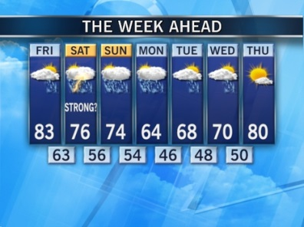
Directions: Answer the following questions by using the provided websites to help you.
- What do you call someone who forecasts the weather? ______________________
______________________________________________________________________________

- What are weather forecasts? _____________________________________________
______________________________________________________________________________
______________________________________________________________________________

- How do meteorologists forecast the weather?______________________________
_____________________________________________________________________________
_____________________________________________________________________________
_____________________________________________________________________________

- What does a 7-Day forecast usually include?______________________________
____________________________________________________________________________
_____________________________________________________________________________
_____________________________________________________________________________
- Based on the research you have done so far, do 7-day forecasts stay the same or change? Why?________________________________________________________
______________________________________________________________________________
______________________________________________________________________________
______________________________________________________________________________
______________________________________________________________________________
Use the table below to create a rough draft of your 7-day forecast on the city you and your team researched.

