Name_______________________ Date________________
Weather Map Creator Research Page
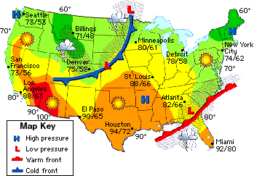
Directions: Answer the following questions by using the provided websites and science book to help you.
- What is a weather map?__________________________________________________
__________________________________________________________________________
__________________________________________________________________________
__________________________________________________________________________

- What do most weather maps have to tell you what each of the symbols mean?

______________________________________________________________________

- There are many different weather maps but all of them show air pressure. How many types of air pressure are there and what are they called?_______________
________________________________________________________________________
________________________________________________________________________

- There are three types of weather fronts shown on a map. List all three and briefly describe what they mean.
A:___________________________________________________________________
_______________________________________________________________________
_______________________________________________________________________

B:_____________________________________________________________________
_______________________________________________________________________
_______________________________________________________________________

C:_____________________________________________________________________
_______________________________________________________________________
_______________________________________________________________________

- Fronts generally move from ____________ to ___________.

- Use the map below to draw an example of what a weather map might look like.

