Name_______________________ Date________________
Weather Tool Expert Research Page
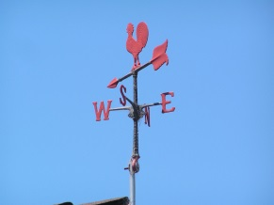
Directions: Choose six weather instruments and write a brief description of each on the lines provided. Make sure to describe what each instrument measures.

Weather Tool 1:_______________________________________________________________
______________________________________________________________________________
______________________________________________________________________________
______________________________________________________________________________

Weather Tool 2:_______________________________________________________________
______________________________________________________________________________
______________________________________________________________________________
_____________________________________________________________________________

Weather Tool 3: _______________________________________________________________
______________________________________________________________________________
______________________________________________________________________________
_____________________________________________________________________________
Weather Tool 4:_______________________________________________________________
______________________________________________________________________________
______________________________________________________________________________
______________________________________________________________________________

Weather Tool 5:_______________________________________________________________
______________________________________________________________________________
______________________________________________________________________________
_____________________________________________________________________________

Weather Tool 6: _______________________________________________________________
______________________________________________________________________________
______________________________________________________________________________
_____________________________________________________________________________
7. What do meteorologists use to measure the moisture in the air (humidity)?_______________________
8. If you wanted to measure the air temperature, what kind of tool would you use? _______________________
9. The weather tool that measures the amount of precipitation that is pictured below is called a ___________________________.
